 

INSTITUTE FOR ADVANCED COMPUTING AND SOFTWARE DEVELOPMENT AKURDI, PUNE

Documentation On

“Yumzy”- An Ecommerce website for Food item Delivery System

PG-DAC SEP 2021

**Submitted By :**

**Group No : 104**

**Roll No. Name:**

**219181 Shivani Bisht**

**219182 Shraddha Patil**

**Mr. Prashant Karhale Mr. Swapnil Golegaonkar**

**Centre Coordinator Project Guide**

# ABSTRACT

Yumzy is an Online Food item Delivery System, the objective of the project is to make an e-commerce website for ordering food item online.

This project is an attempt to provide the advantages of ordering food item online to customers. In this system the customer no more needs to go to the restaurant for buying the food item, rather he/she can buy the food item of the restaurant anywhere through the internet by using an online portal at his/her ease. Thus, the customer will get the service of online Restaurant and home delivery from his favorite Restaurant. This system can be implemented to any Restaurant in the locality or to multinational branded Restaurants and retail outlet chains.

If such food item ordering systems are providing an online portal where their customers can enjoy ease of ordering food item from anywhere, the Restaurants won’t be losing any more customers to the trending online food item ordering systems such as Zomato or Swiggy. Since this application can be used easily via internet hence it is accessible and always available.

# ACKNOWLEDGEMENT

We take the opportunity to thank all those people who have helped and guided us through this project and has made this experience worthwhile for us. We wish to sincerely thank our esteemed guide, **Mr. Swapnil Golegaonkar** for providing us with the right guidance and advice at the crucial junctures. We would also like to thank our respected **Centre Co-Ordinator Mr. Prashant Karhale**, for allowing us to use the facilities available. We would also like to thank **Mr. Narendra Pawar** for guiding us throughout the project and encouraging us to explore this domain. Last but not the least we would like to thank our teaching and non-teaching staff for their immense support and cooperation.

**Shivani Bisht (219181) Shraddha Patil (219182)**

**Table of Contents**

[ABSTRACT 2](#_bookmark0)

[ACKNOWLEDGEMENT 3](#_bookmark1)

[INTRODUCTION 7](#_bookmark2)

[FEATURES 7](#_bookmark3)

* 1. [PROJECT OBJECTIVE 8](#_bookmark4)
  2. [PROJECT OVERVIEW 8](#_bookmark5)
  3. [PROJECT SCOPE 8](#_bookmark6)
  4. [STUDY OF THE SYSTEM 9](#_bookmark7)
     1. [MODULES 9](#_bookmark8)

[SYSTEM ANALYSIS 19](#_bookmark9)

* 1. [EXISTING SYSTEM 19](#_bookmark10)
  2. [PROPOSED SYSTEM 19](#_bookmark11)
  3. [SYSTEM REQUIREMENT SPECIFICATION 19](#_bookmark12)
     1. [GENERAL DESCRIPTION 19](#_bookmark13)
     2. [SYSTEM OBJECTIVES 20](#_bookmark14)
     3. [SYSTEM REQUIREMENTS 20](#_bookmark15)

[MODERATOR 23](#_bookmark16)

[DESCRIPTION OF FEATURES 23](#_bookmark17)

[ADMIN 23](#_bookmark18)

[SYSTEM DESIGN 25](#_bookmark19)

* 1. [INPUT AND OUTPUT DESIGN 25](#_bookmark20)
     1. [INPUT DESIGN 25](#_bookmark21)
     2. [OUTPUT DESIGN 25](#_bookmark22)

[DATABASE DESIGN 27](#_bookmark23)

* 1. [DATABASE 27](#_bookmark24)
  2. [SYSTEM TOOLS 27](#_bookmark25)
     1. [FRONT END 27](#_bookmark26)
     2. [BACKEND 27](#_bookmark27)

[1 LEVEL DFD FOR ADMIN 28](#_bookmark28)

[1 LEVEL DFD FOR CUSTOMER 29](#_bookmark29)

[E-R DIAGRAM 29](#_bookmark30)

[CLASS DIAGRAM 31](#_bookmark31)

[TABLE STRUCTURE 31](#_bookmark32)

[PROJECT DIAGRAMS 36](#_bookmark33)

[CONCLUSION 45](#_bookmark34)

[REFERENCES 46](#_bookmark35)

**LIST OF FIGURES**

**FIGURE 1 : ADMIN ACTIVITY DIAGRAM 11**

**FIGURE 2 : SUPPLIER ACTIVITY DIAGRAM 13**

**FIGURE 3 : CUSTOMER ACTIVITY DIAGRAM 15**

**FIGURE 4 : DELIVERY BOY ACTIVITY DIAGRAM 17**

**FIGURE 5 : 1 LEVEL DFD FOR ADMIN 28**

**FIGURE 6 : 1 LEVEL DFD FOR CUTOMER 29**

**FIGURE 7 : E-R DIAGRAM 30**

**FIGURE 8 : CLASS DIAGRAM 31**

**FIGURE 9 : TABLE STRUCTURE 31**

**FIGURE 10 : PROJECT DIAGRAMS 36**

# INTRODUCTION

**“Yumzy”** is an e-commerce website for ordering food item online. This project is an attempt to provide the advantages of ordering food item online to customers. In this system the customer no more needs to go to the restaurant for buying the food item, rather he/she can buy the food item of the restaurant anywhere through the internet by using an online portal at his/her ease. Thus, the customer will get the service of ordering food online and home delivery from his/her favorite Restaurant.

The objective of the project is to make an ecommerce food ordering website to purchase food items from an existing Restaurant. In order to build such website, a complete web support, needs to be provided. In this project we aim to build a complete and efficient web based portal which can provide the online food ordering experience.

**Features** :-

1. Food item Available-Idli,Dosa,Puran Poli,Coffee,Burger etc.
2. Search for green (fruits/vegetables) food item easily
3. Category of food item- Maharastrian,Punjabi,South Indian,American etc.
4. Cart feature
5. Date and time of food item delivery will be notified by the system
6. The Admin can add/delete Suppliers and delivery boys.
7. Allows the customers to maintain cart.
8. Asks for address.
9. Give facility to choose payment type.
   1. **PROJECT OBJECTIVE**

The objective of the project is to make an ecommerce food ordering website to purchase food items from an existing Restaurant. In order to build such website, a complete web support, needs to be provided. In this project we aim to build a complete and efficient web based portal which can provide the online food ordering experience.

* 1. **PROJECT OVERVIEW**

The central concept of the website is to allow the customer to order virtually using the internet and allow customers to buy the food of their desired Restaurant. The information pertaining to the food items are stores on an RDBMS at the server side (store).

The server processes the customers, and the food items are shipped to the address submitted by them. The application was designed into two modules first is for the customers who wish to buy the food items. Second is for the supplier who maintains and updates the information pertaining to the food items and those of this food item is a departmental store where the application is hosted on the web and the administrator maintains the database. The application, which is deploy the customer database, the details of the food items are brought forward from the database for the customer view based on the selection through the menu and the database of all the food item are updated at the end of each transaction. Data entry into the application can be done through various screens designed for various levels of users. Once the authorized personal feed the relevant data into the system, several reports could be generated as per the security.

* 1. **PROJECT SCOPE**

This system can be implemented to any Restaurant in the locality or to multinational branded Restaurants

having retail outlet chains. The system recommends a facility to accept the orders 24X7 and a home delivery system which can make customers happy. If Restaurants are providing an online portal where their customers can enjoy easy ordering food from anywhere, the Restaurants wont be losing any more customers to the trending online Restaurants such as Zomato or Swiggy. Since the application is available and always available.

* 1. **STUDY OF THE SYSTEM**

## MODULES :

The system after careful analysis has been identified to be presented with the following modules and roles.

The modules involved are :

* + - * Administrator
      * Supplier
      * Users
      * Delivery Boy
      1. Administrator :

The administrator is the super user of this portal. Only admin have access into this admin page. Admin may be the owner of the Restaurant. The administrator has all the information about the users and about all food items.

This module is divided into different sub modules.

* + - * 1. Manage Suppliers
        2. Manage Food item
        3. Manage Users
        4. Manage Orders
        5. Manage Delivery Boy

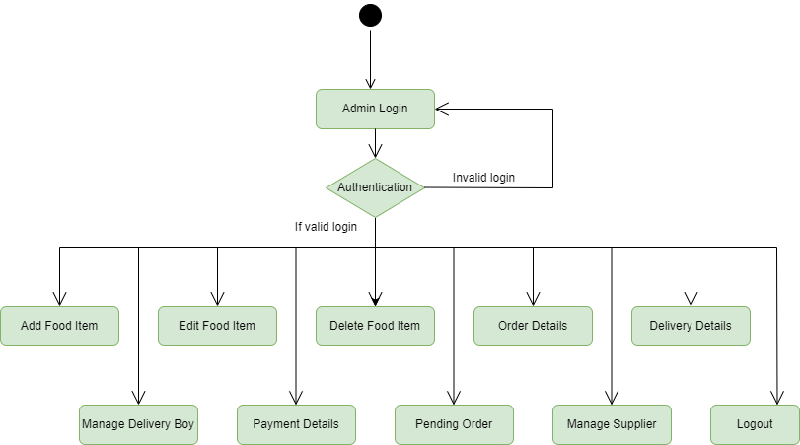

*Figure 1 Admin Activity Diagram*

* **Add Food item**

The Food Ordering cart contains different kinds of food item of different category. The food item can be classified into different categories by name. Admin can add new food item into the existing system with all its details including an image.

* **Delete Food item**

Administrator can delete the food item based on the stock of that particular food item .

* **Search Food item**

Admin will have a list view of all the existing food item. He can also search for a particular food item by name.

* **Add Delivery Boy**

Admin can add delivery boy for the system. Admin can see the details of delivery boy and the order delivery.

* **Remove Delivery Boy**

Admin have the privilege to remove the delivery boy.

* **Add Supplier**

Admin have the privilege to add the supplier and according to category he can add food item and he can manage the available food item stocks.

* **Remove Supplier**

Admin have the privilege to remove the supplier.

* **Search Food item**

Only admin is having the privilege to add a supplier. He can search the food item to manage the food item .

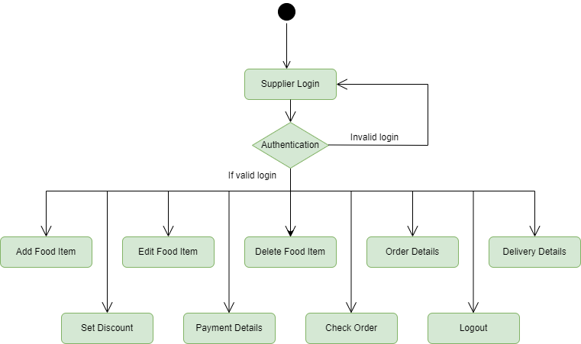

*Figure 2 Supplier Activity Diagram*

* **Edit Food item**

Supplier can edit his added food item.

* **Set Discounts**

Supplier can set discounts to the food item.

* **Delivered Orders**

Supplier can see order details of the ordered food item by the customer.

* **Pending Orders**

Supplier can see order details of the ordered food item by the customer.

* P**ayments**

Supplier can see payment details of the ordered food item by the customer.

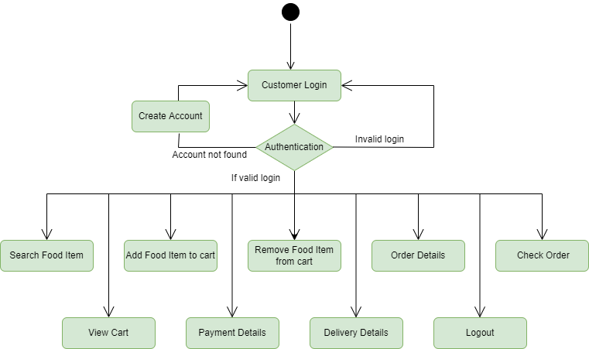

*Figure 3 Customer Activity Diagram*

* + **Customer sign in, sign out, create account**

This feature is provided to customer so he can sign in, sign out and create account for new customer.

* + **Search Food item**

Customer can search the food item as per his wish in specific category.

* + **Add to Cart**

Customer can add food item to cart which he wants to buy the food item.

* + **Payments**

Customer have a privilege to his order he can see his order details.

* + **Order Details**

Customer have a privilege to his order he can see his order details.

* + **Buy Food item**

Customers can buy food item from his cart by doing payment.

* + **Wish List**

Customer can have a wish list for future buying food item he can add food item in the wish to list.

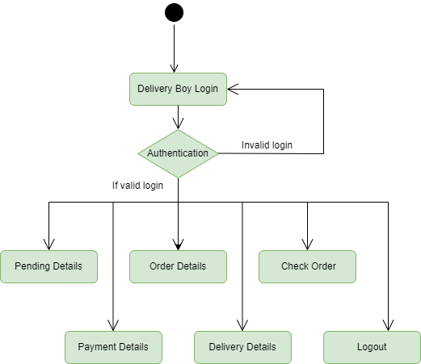

*Figure 4 Delivery Boy Activity Diagram*

* **Delivery Boy sign in, sign out**

This feature is provided to Delivery Boy so he can sign in, sign out and delivery boy is added by admin.

* **Pending Orders**

Delivery boy can see the pending order details after sign in account.

* **Delivered Orders**

Delivery boy can see the delivered order details after sign in account.

* **Payment History**

Delivery boy can see the payment history of his food item.

# SYSTEM ANALYSIS

System analysis is the process of gathering and interpreting facts, diagnosing problems, and using the information to recommend improvements on the system. System analysis is a problem-solving activity that requires intensive communication between the system users and system developers.

System analysis or study is an important phase of any system development process. The system is viewed as a whole, the inputs are identified, and the system is subjected to close study to identify the problem areas. The solutions are given as a proposal. The proposal is reviewed on user request and suitable changes are made. This loop ends as soon as the user is satisfied with the proposal.

* 1. **EXISTING SYSTEM**

The current system for ordering food is to visit the Restaurant manually and from the available food item choose the item customer want and buying the item by payment of the price of the item.

* + - It is less user-friendly.
    - User must go to Restaurant and select food item.
    - It is difficult to identify the required food item.
    - Description of the food item limited.
    - It is a time-consuming process
    - Not in reach of distant users.
  1. **PROPOSED SYSTEM**

In the proposed system customer need not go to the Restaurant for buying the food item. He can order the food item he wish to buy through the website or portal. The Restaurant owner will be admin of the system. Restaurant owner can appoint suppliers who will help owner in managing the customers and food item orders. The system also recommends a home delivery system for the purchased food item.

* 1. **SYSTEM REQUIREMENT SPECIFICATION**
     1. **GENERAL DESCRIPTION Food item Description :**

The system consists of two parts. A website which can provide the online Restaurant service for the customer to access the web service from his Smartphone/System. Website should be able to help the customer for selecting his item and to help the owner in managing the orders from the customers.

**Problem Statement :**

As online food ordering became a trend nowadays the regular Restaurants are losing their customers to online brands. Customers have effortless food ordering experience and saving time through ordering online. For competing with those online brands, if Restaurants are providing an online portal where their customers can order through internet and get the food item at their doors it will increase the number of customers.

* + 1. **SYSTEM OBJECTIVES**
       - To provide a Website for online ordering of food item in an existing Restaurant.
       - To provide an online food ordering web site for the same Restaurant.
    2. **SYSTEM REQUIREMENTS**
       1. **NON-FUNCTIONAL REQUIREMENTS**
          1. **EFFICIENCY REQUIREMENT**

When an online food ordering cart portal or website implemented customer can purchase food item in efficient manner.

* + - * 1. **RELIABILITY REQUIREMENT**

The system should provide a reliable environment to both customers and owner. All orders should be reaching at the admin without any errors.

* + - * 1. **USABILITY REQUIREMENT**

The Website is designed for user friendly environment and ease of use.

* + - * 1. **IMPLEMENTATION REQUIREMENT**

Implementation of the system using React in front end with Spring Boot as back end and it will be used for database connectivity. And the database part is developed by MySQL. Responsive web designing is used for making the website compatible for any type of screen.

* + - * 1. **DELIVERY REQUIREMENT**

The whole system is expected to be delivered in four months of time with a weekly Evaluation by the project guide.

* + - 1. **FUNCTIONAL REQUIREMENTS**

**USER**

* **USER LOGIN Description of feature**

This feature used by the user to login into system. A user must login with his username and password to the system after registration. If they are invalid, the user not allowed to enter the system.

**Functional Requirement**

* Username and password will be provided after user registration is confirmed.
* Password should be hidden from others while typing it in the field
* **REGISTER NEW**

**USER Description of feature**

A new user will have to register in the system by providing essential details in order to view the food item in the system. The admin must accept a new user by unblocking him.

**Functional Requirement**

* System must be able to verify and validate information.
* The system must encrypt the password of the customer to provide security.
* **PURCHASING AN ITEM Description of feature**

The user can add the desired food item into his cart by clicking add to cart option on the food item. He can view his cart by clicking on the cart button. All food item added by cart can be viewed in the cart. User can remove an item from the cart by clicking remove. After confirming the food items in the cart, the user can submit the cart by providing a delivery address. On successful submitting the cart will become empty.

**Functional Requirement**

* System must ensure that, only a registered customer can purchase food items.
* Admin account should be secured so that only owner of the Restaurant can access that account

# MODERATOR

**Description of features**

A moderator is considered as a staff who can manage orders for the time being. As a future update moderator may give facility to add and manage his own food item. Moderators can reduce the workload of admin. Now moderator has all the privilege of an admin having except managing other moderators. He can manage users and manage food item. He can also check the orders and edit his profile.

**Functional Requirement**

* The system must identify the login of a moderator.

**ADMIN**

* **MANAGE USER Description of features**

The administrator can add user, delete user, view user.

* **MANAGE MODERATOR Description of features**

The administrator can add moderator, delete moderator and search for a moderator.

* **MANAGE FOOD ITEM Description of features**

The administrator can add food item, delete food item, and view food item.

* **MANAGE ORDER Description of features**

The administrator can view orders and delete orders.

**Functional Requirements :**

* The system must identify the login of the admin.
* Admin account should be secured so that only owner of the Restaurant can access that account.

**MODERATOR**

**Description of features**

A moderator is considered as a staff who can manage orders for the time being. As a future update moderator may give facility to add and manage his own food item. Moderators can reduce the workload of admin. Now moderator has all the privilege of an admin having except managing other moderators. He can manage users and manage food item. He can also check the orders and edit his profile.

**Functional Requirement**

* The system must identify the login of a moderator.

# SYSTEM DESIGN

System design is the solution for the creation of a new system. This phase focuses on the detailed implementation of the feasible system. Its emphasis on translating design. Specifications to performance specification. System design has two phases of development.

* Logical Design
* Physical Design

During logical design phase the analyst describes inputs (sources), outputs(destinations), databases (data sores) and procedures (data flows) all in a format that meets the user requirements. The analyst also specifies the needs of the user at a level that virtually determines the information flow in and out of the system and the data resources. Here the logical design is done through data flow diagrams and database design. The physical design is followed by physical design or coding. Physical design produces the working system by defining the design specifications, which specify exactly what the candidate system must do. The programmers write the necessary programs that accept input from the user, perform necessary processing on accepted data and produce the required report on a hard copy or display it on the screen.

* 1. **INPUT AND OUTPUT DESIGN**
     1. **INPUT DESIGN :**

Input design is the link that ties the information system into the world of its users. The input design involves determining the inputs, validating the data, minimizing the data entry and provides a multi-user facility. Inaccurate inputs are the most common cause of errors in data processing. Errors entered by the data entry operators can be controlled by input design. The user-originated inputs are converted to a computer-based format in the input design. Input data are collected and organized into groups of similar data. Once identified, the appropriate input media are selected for processing. All the input data are validated and if any data violates any conditions, the user is warned by a message. If the data satisfies all the conditions, it is transferred to the appropriate tables in the database. In this project the student details are to be entered at the time of registration. A page is designed for this purpose which is user friendly and easy to use. The design is done such that users get appropriate messages when exceptions occur.

* + 1. **OUTPUT DESIGN :**

Computer output is the most important and direct source of information to the user. Output design

Is very important phase since the output needs to be in an efficient manner. Efficient and intelligible output design improves the system relationship with the user and helps in decision making. Allowing the user to view the sample screen is important because the user is the ultimate judge of the quality of output. The output module of this system is the selected notifications.

# DATABASE DESIGN

* 1. **DATABASE**

Databases are the storehouses of data used in the software systems. The data is stored in tables inside the database. Several tables are created for the manipulation of the data for the system. Two essential settings for a database are

* Primary key - the field that is unique for all the record occurrences
* Foreign key - the field used to set relation between tables Normalization is a technique to avoid redundancy in the tables.
  1. **SYSTEM TOOLS**

The various system tools that have been used in developing both the front end and the back end of the project are being discussed in this chapter.

* + 1. **FRONT END :**

React is a library which is developed by Facebook are utilized to implement the frontend. React (also known as React.js or ReactJS) is a [free and open-source](https://en.wikipedia.org/wiki/Free_and_open-source_software) [front-end](https://en.wikipedia.org/wiki/Front_end_and_back_end) [JavaScript](https://en.wikipedia.org/wiki/JavaScript_library) [library](https://en.wikipedia.org/wiki/JavaScript_library) for building [user interfaces](https://en.wikipedia.org/wiki/User_interfaces) or UI components. It is maintained by [Facebook](https://en.wikipedia.org/wiki/Facebook%2C_Inc) and a community of individual developers and companies. React can be used as a base in the development of [single page](https://en.wikipedia.org/wiki/Single-page_application) or mobile applications. However, React is only concerned with state management and rendering that state to the [DOM](https://en.wikipedia.org/wiki/Document_Object_Model), so creating React applications usually requires the use of additional libraries for routing, as well as certain client-side functionality.

* + 1. **BACKEND :**

The back end is implemented using MySQL which is used to design databases.

**MySQL :**

MySQL is the world's second most widely used open-source relational database management system (RDBMS). The SQL phrase stands for Structured Query Language .An application software called Navicert was used to design the tables in MySQL.

**Spring-Boot :**

This is used to connect MYSQL and fetch data from database and store the data in database. The Spring Framework is an [application framework](https://en.wikipedia.org/wiki/Application_framework) and [inversion of control](https://en.wikipedia.org/wiki/Inversion_of_control) [container](https://en.wikipedia.org/wiki/Servlet_container) for the [Java platform.](https://en.wikipedia.org/wiki/Java_platform) The framework's core features can be used by any Java application, but there are extensions for building web applications on top of the [Java EE](https://en.wikipedia.org/wiki/Java_EE) (Enterprise Edition) platform. Although the framework does not impose any specific [programming model](https://en.wikipedia.org/wiki/Programming_model), it has become popular in the Java community as an addition to the [Enterprise JavaBeans](https://en.wikipedia.org/wiki/Enterprise_JavaBeans) (EJB) model. The Spring Framework is Open-source Framework.

**0 Level DFD for Admin**

**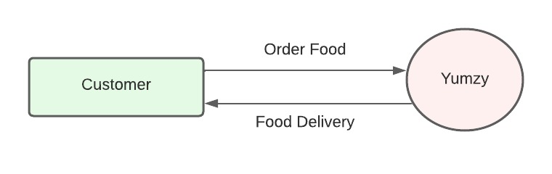**

*Fig. 0 Level DFD for Admin*

# 

# 1 Level DFD for ADMIN

**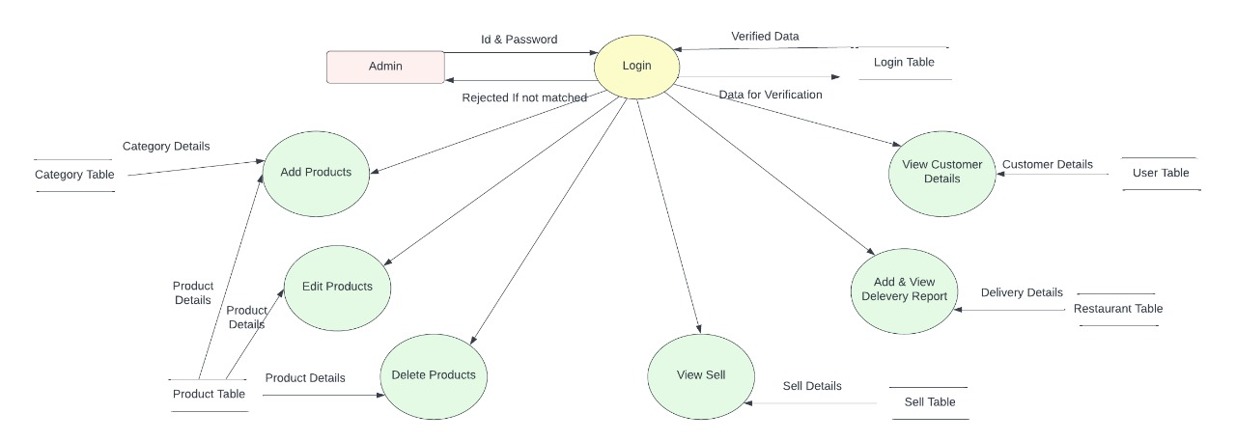**

# *Fig. 1 Level DFD for Admin*

# 1 Level DFD for CUSTOMER

# C:\Users\Administrator\Downloads\WhatsApp Image 2022-04-12 at 8.37.09 PM (1).jpeg

*Fig. 1 Level DFD for CUSTOMER*

**Use Case Diagram :**

**Admin Use Case :**

**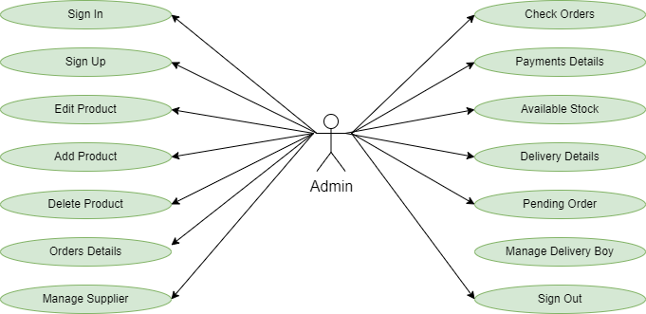**

# 

# *Fig. Admin Use Case*

# Supplier Use Case :

# E:\cdac_iacsd_2021\PROJECT-CDAC\cdac_project\Activity Diagrams\Supplier.png

# *Fig. Supplier Use Case*

# Customer Use Case :

# E:\cdac_iacsd_2021\PROJECT-CDAC\cdac_project\Activity Diagrams\Customer.png

# *Fig. Customer Use Case*

# Delivery Boy Use Case :

# E:\cdac_iacsd_2021\PROJECT-CDAC\cdac_project\Activity Diagrams\Delivery Boy.png

# *Fig. Delivery Boy Use Case*

# E-R Diagram

# C:\Users\Administrator\Downloads\WhatsApp Image 2022-04-12 at 9.42.38 PM.jpeg

*Figure 7 E-R Diagram*

# Class Diagram

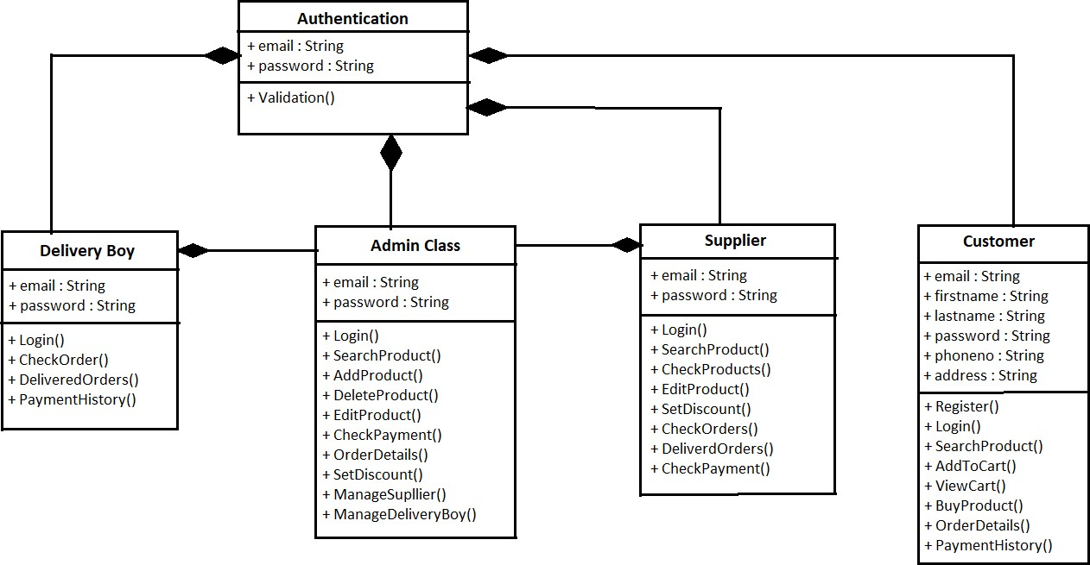

*Figure 8 Class Diagram*

# TABLE STRUCTURE:

**Tables :**

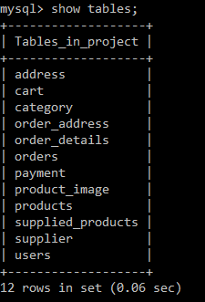

**Address:**

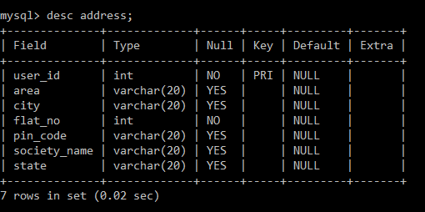

**Cart :**

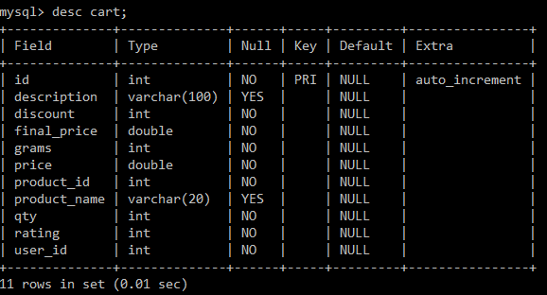

**Category:**

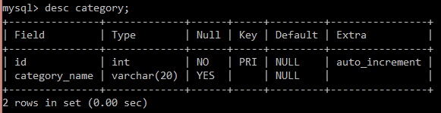

**Order Address:**

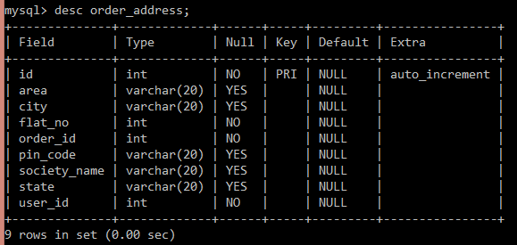

**Order Details :**

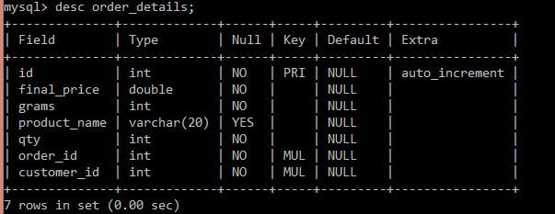

**Orders :**

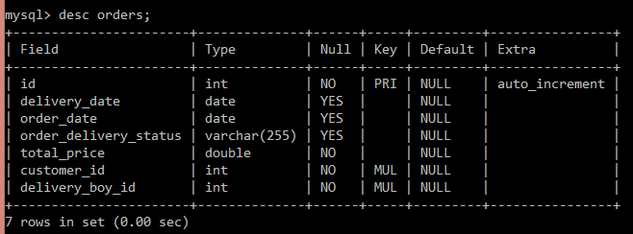

**Food item :**

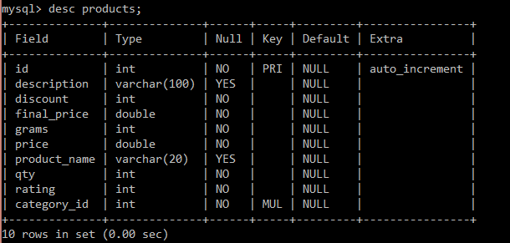

**Food item item Image :**

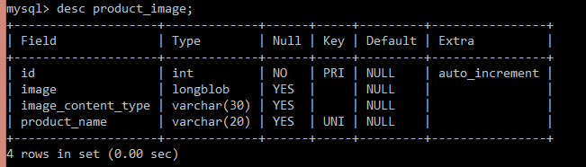

**Payment :**

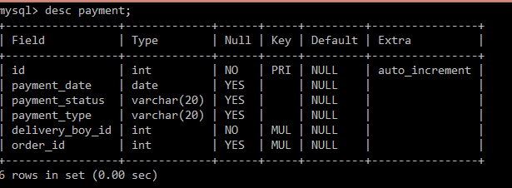

**Supplied Food item :**

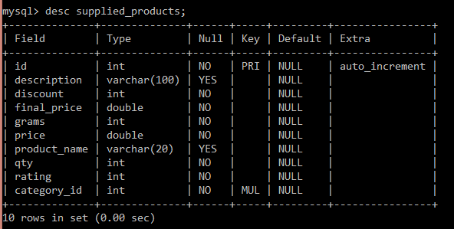

**Supplier :**

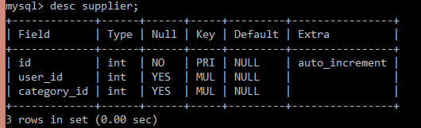

**Users :**

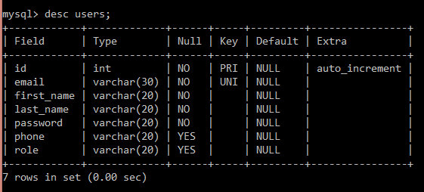

# 

# PROJECT DIAGRAMS

# Home Page

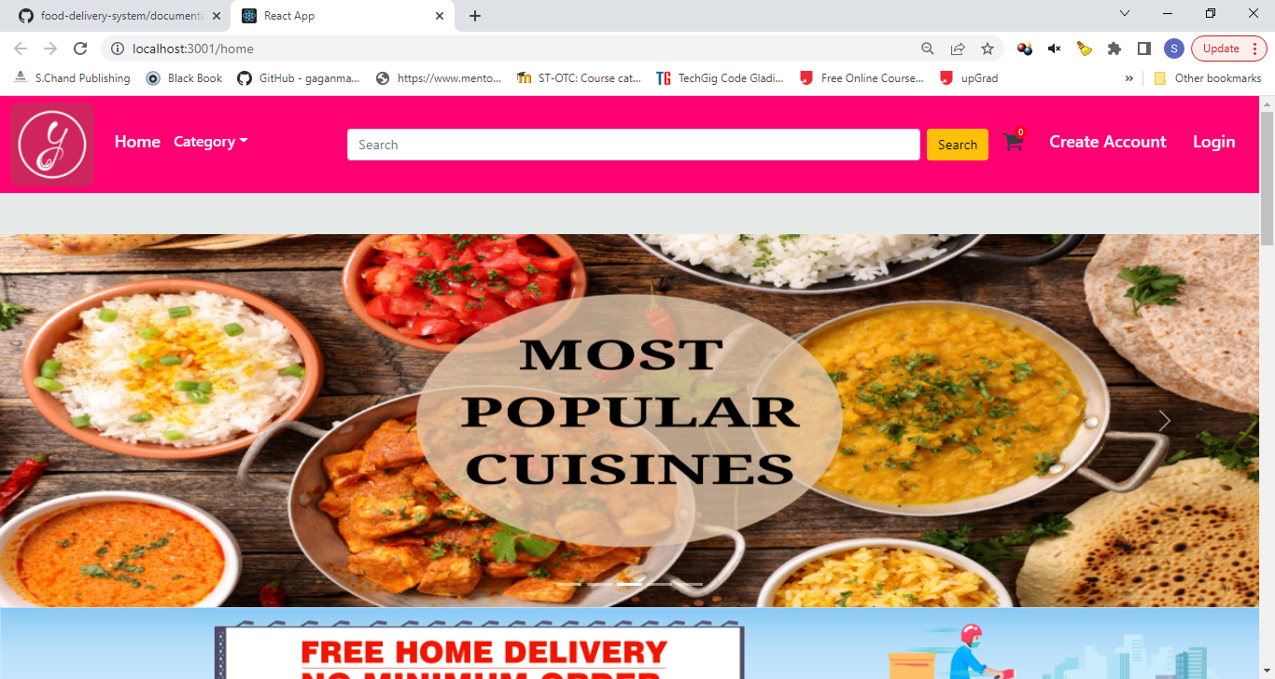

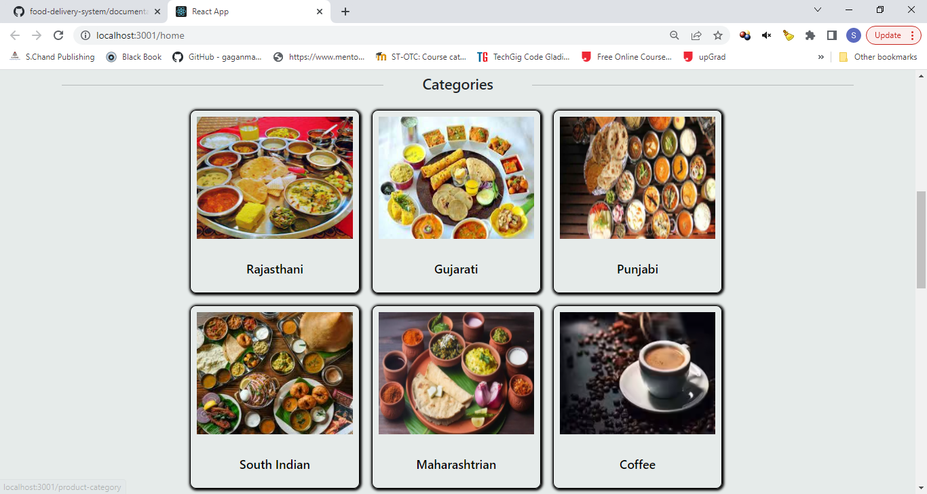

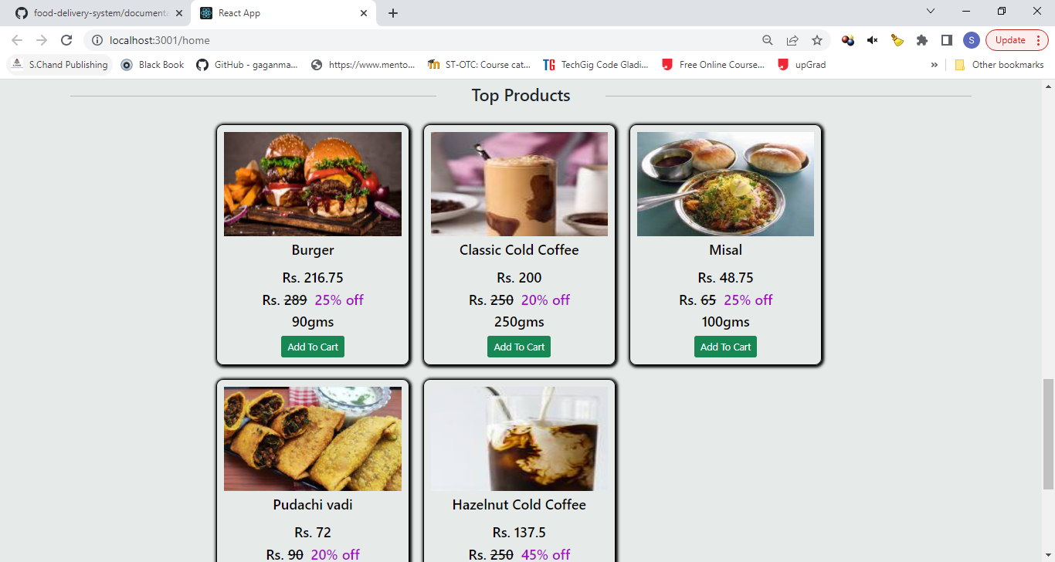

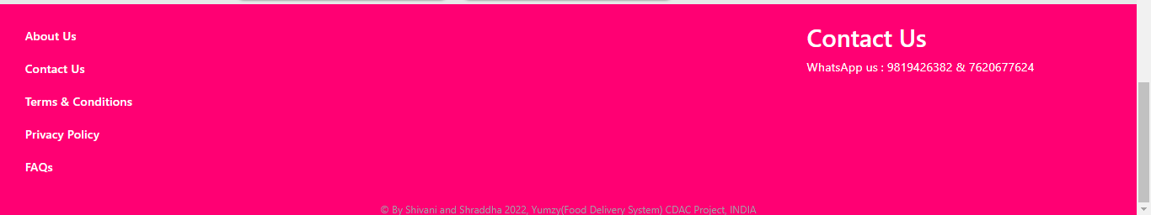

### Admin Login Page

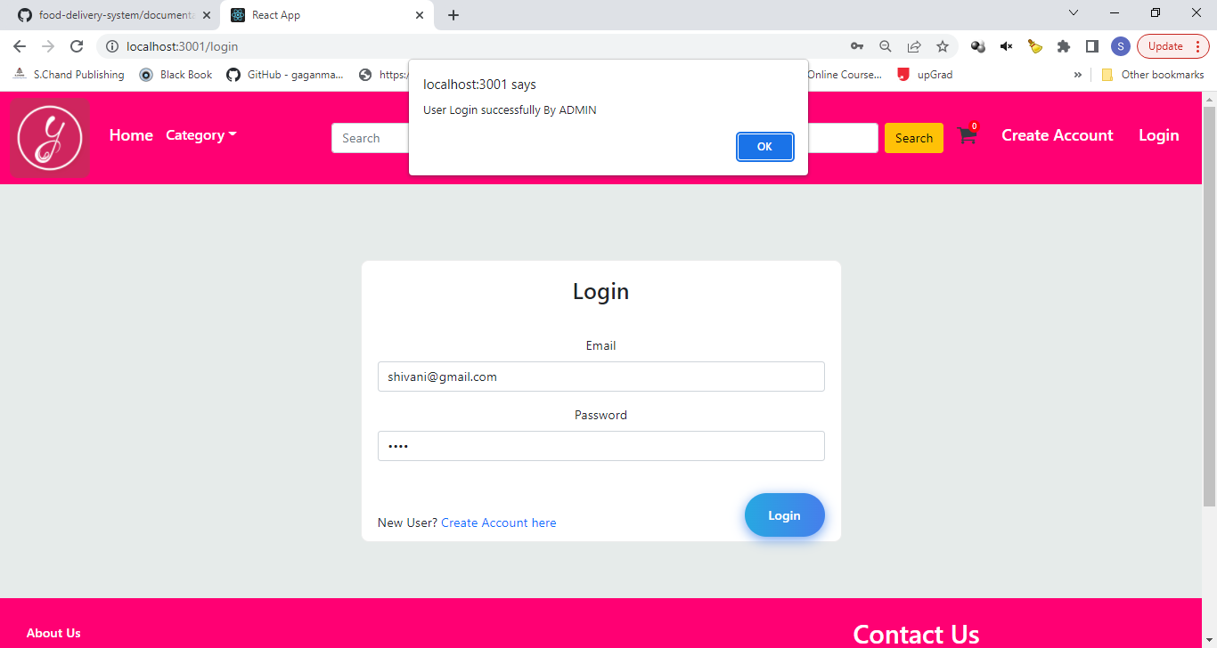

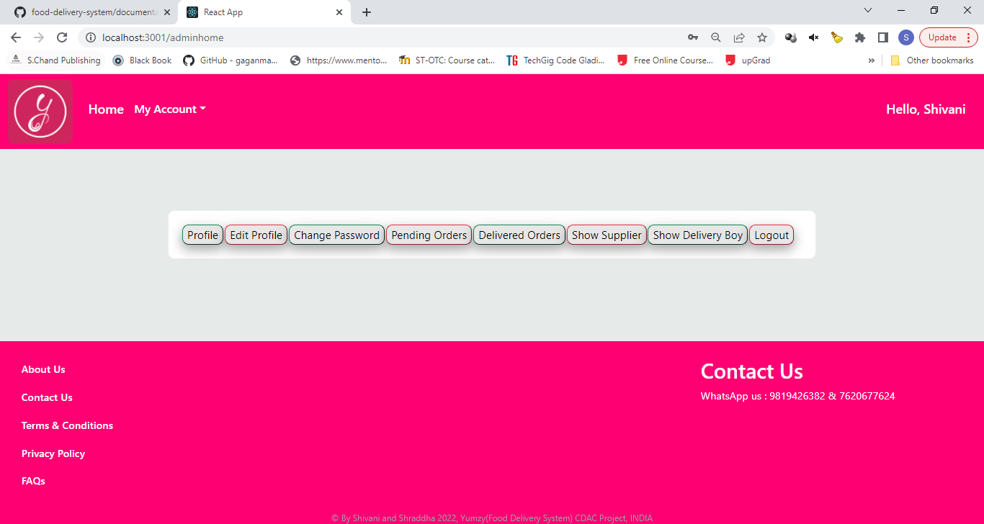

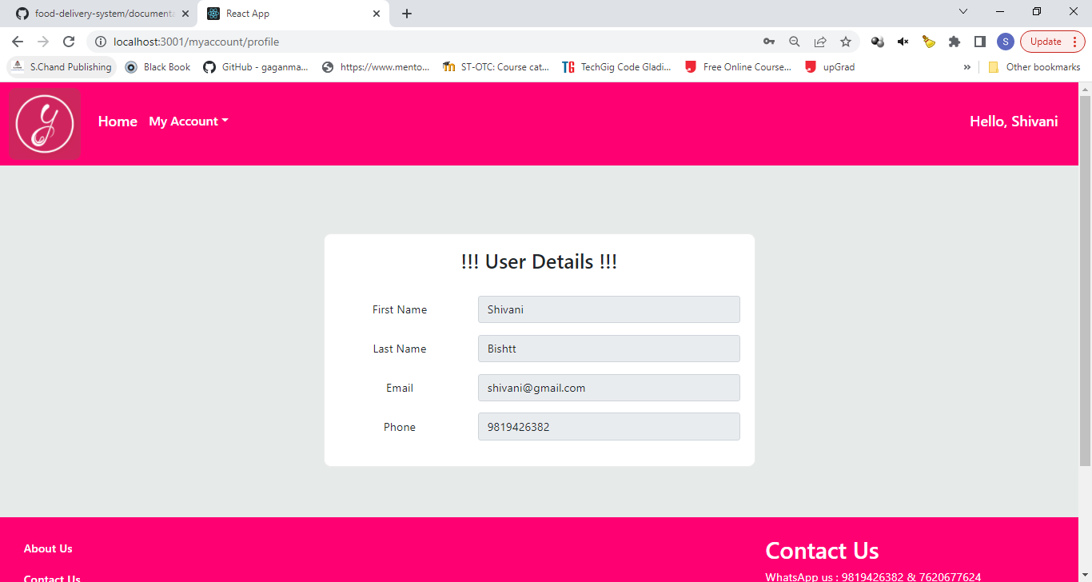

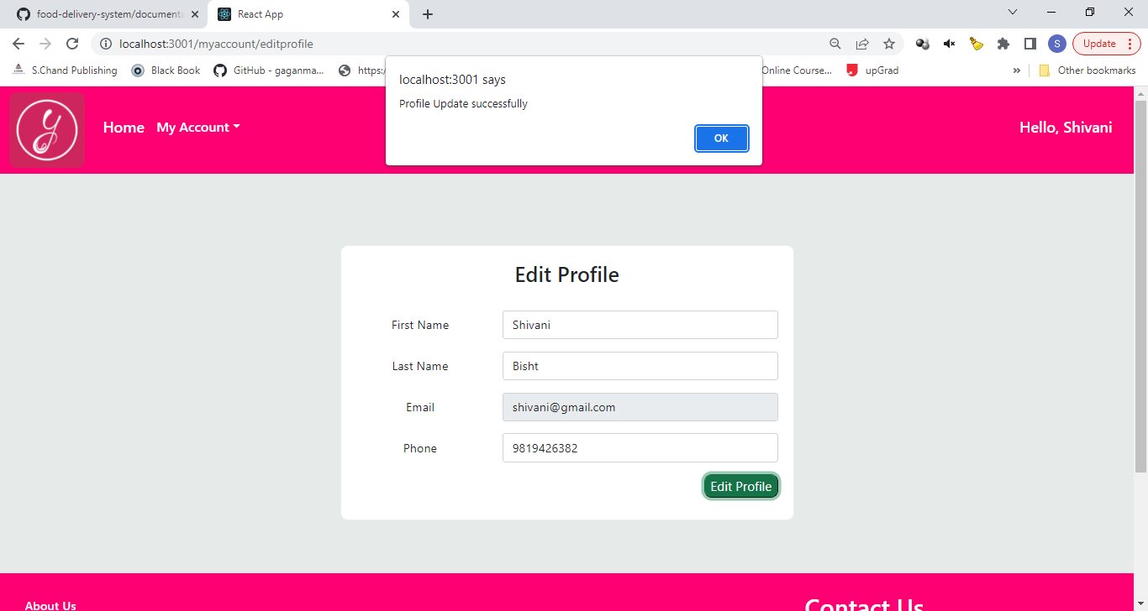

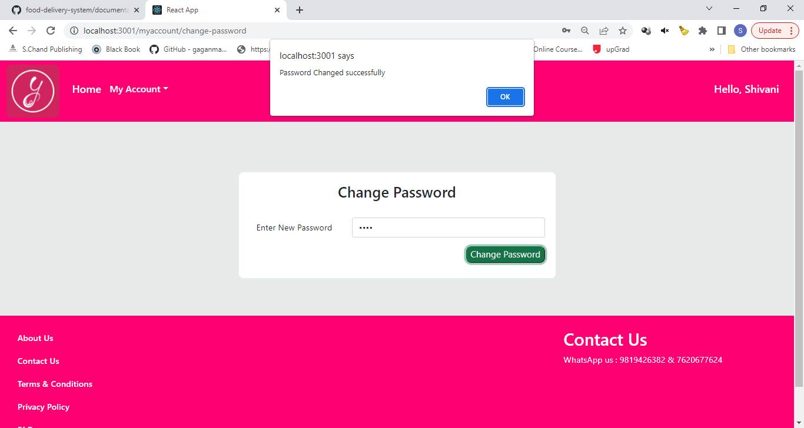

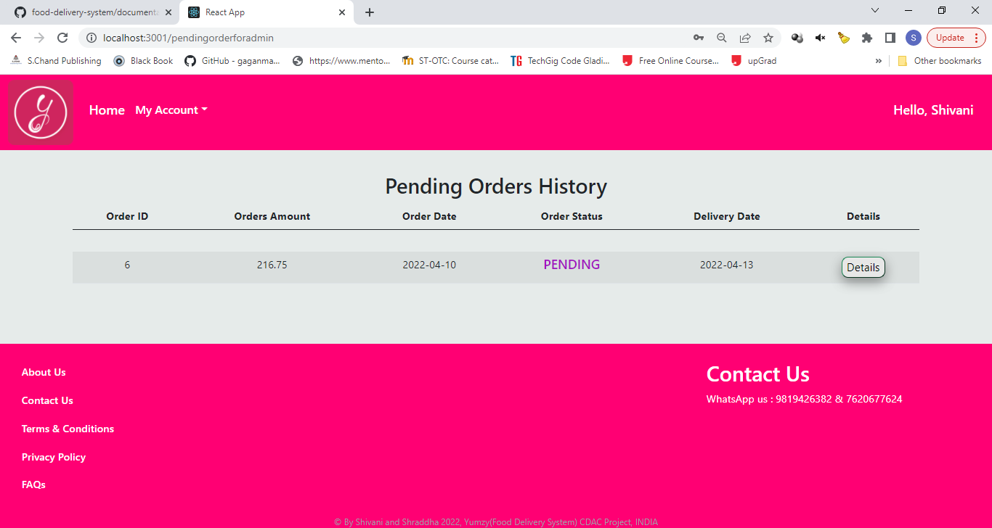

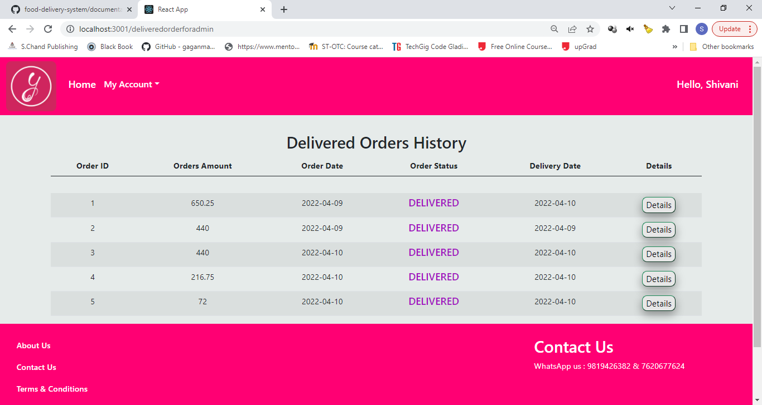

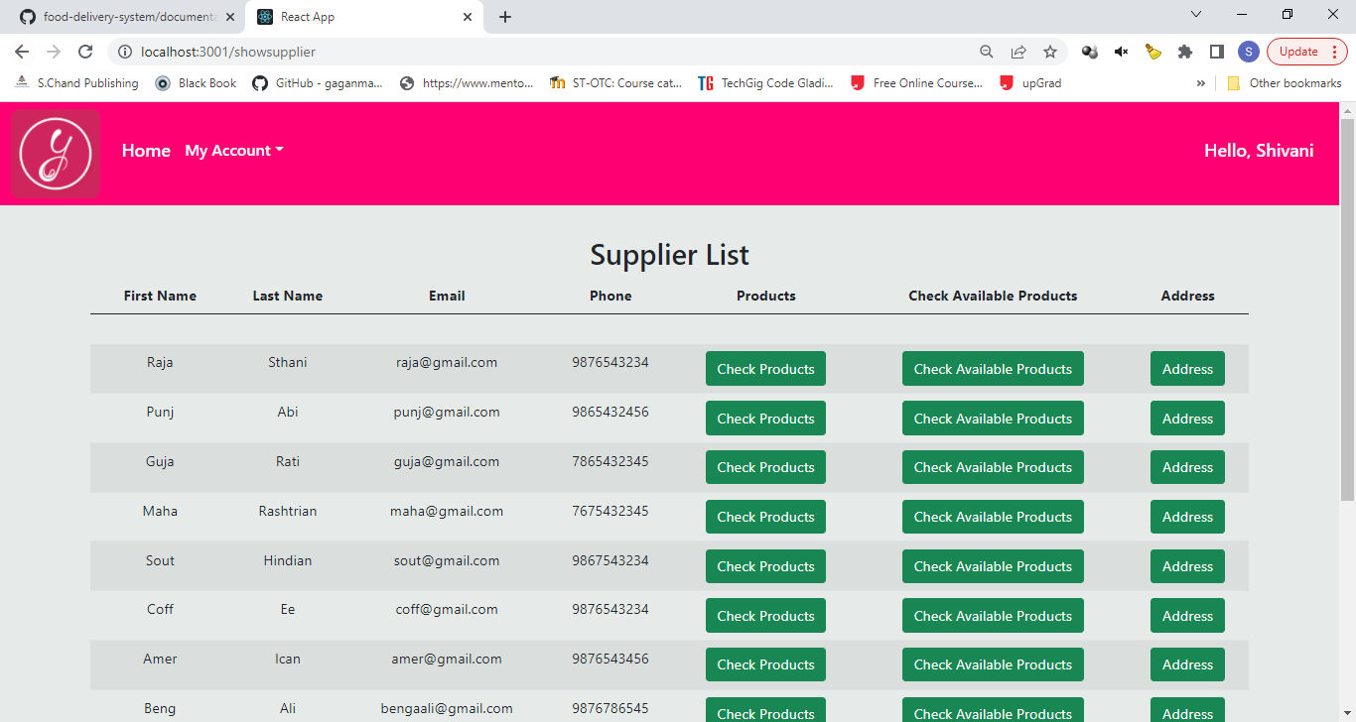

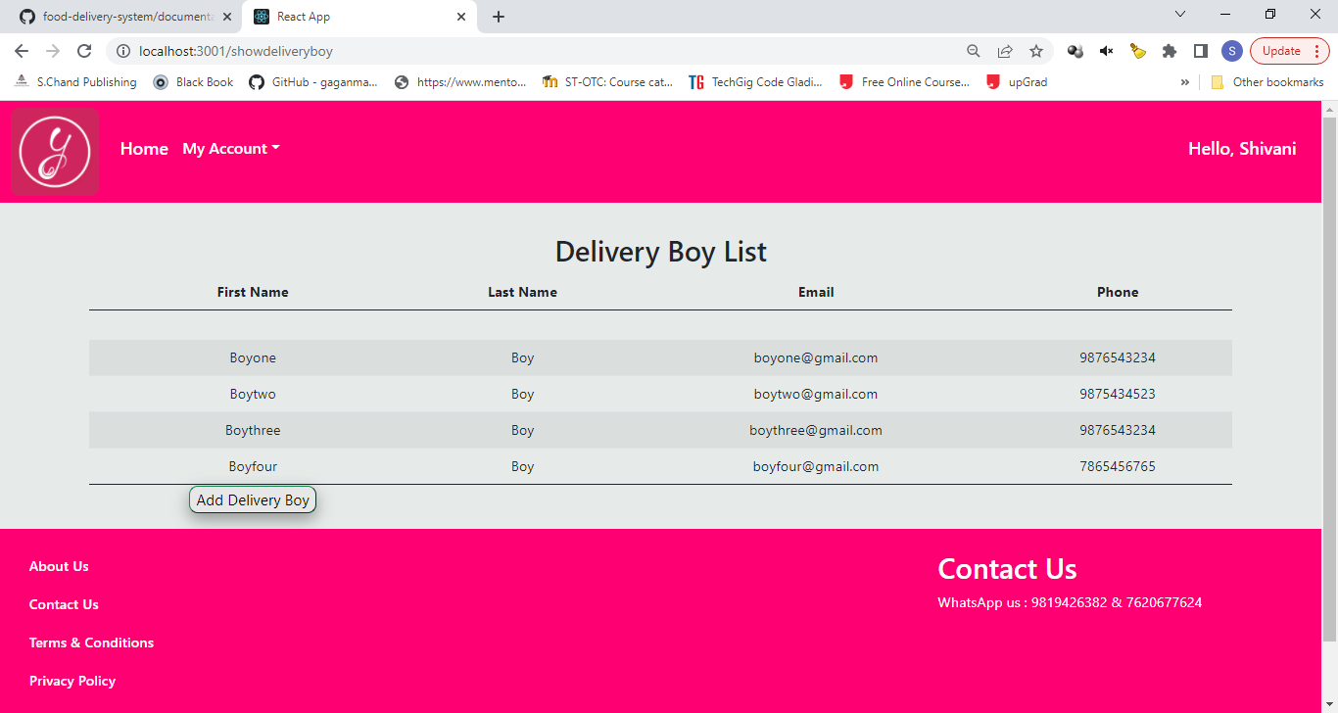

**Supplier Login Page**

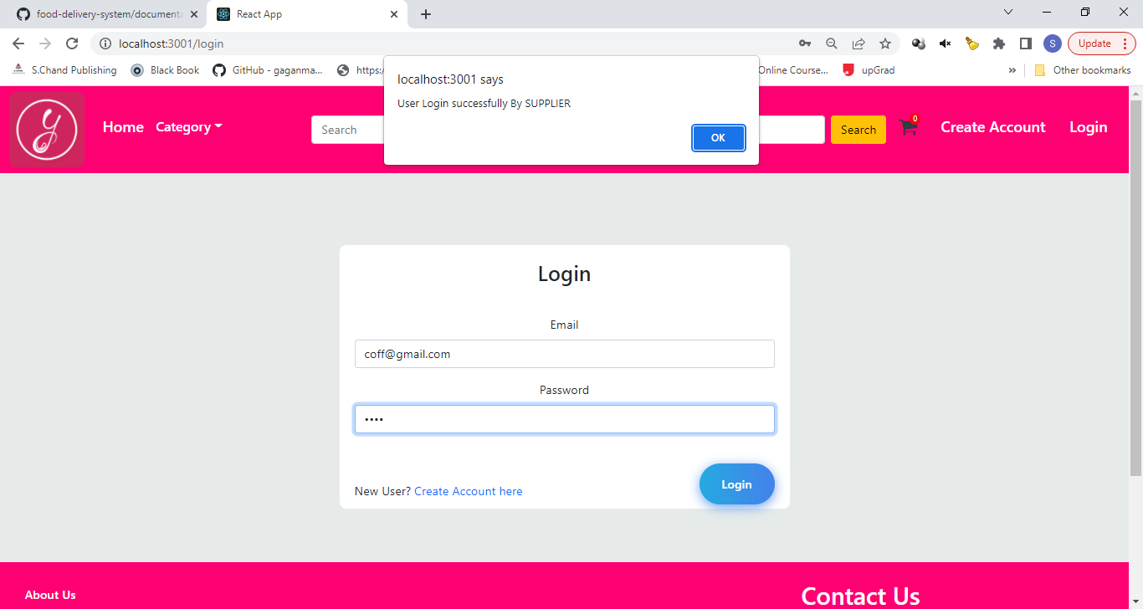

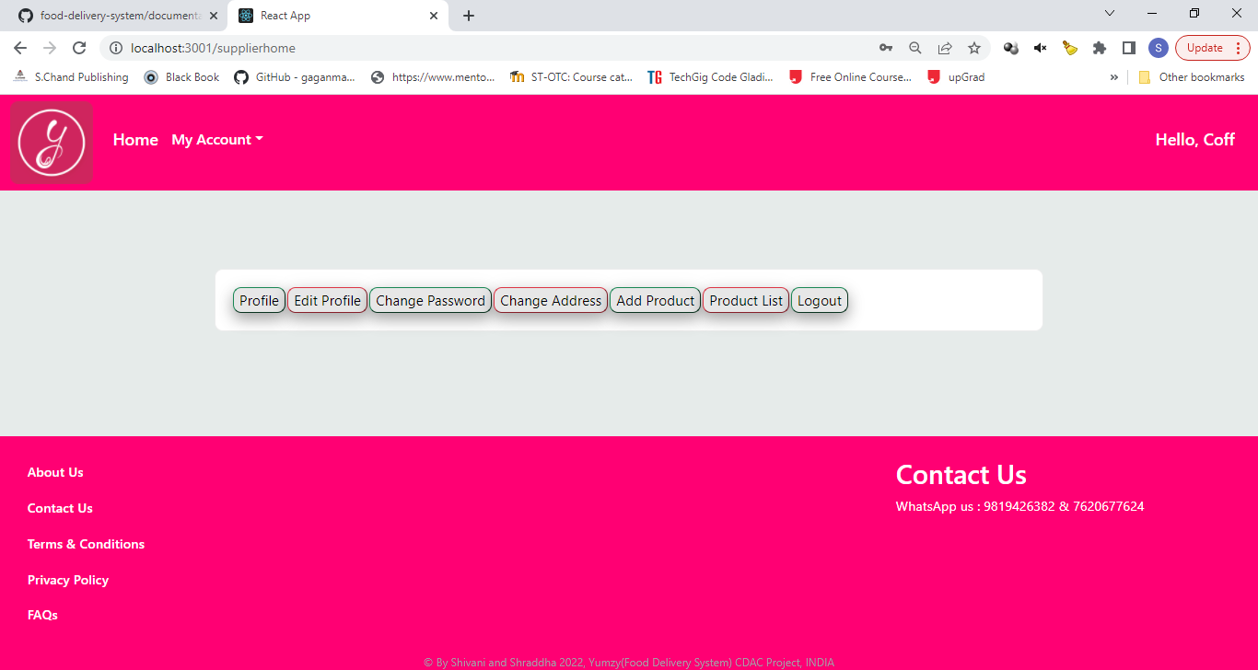

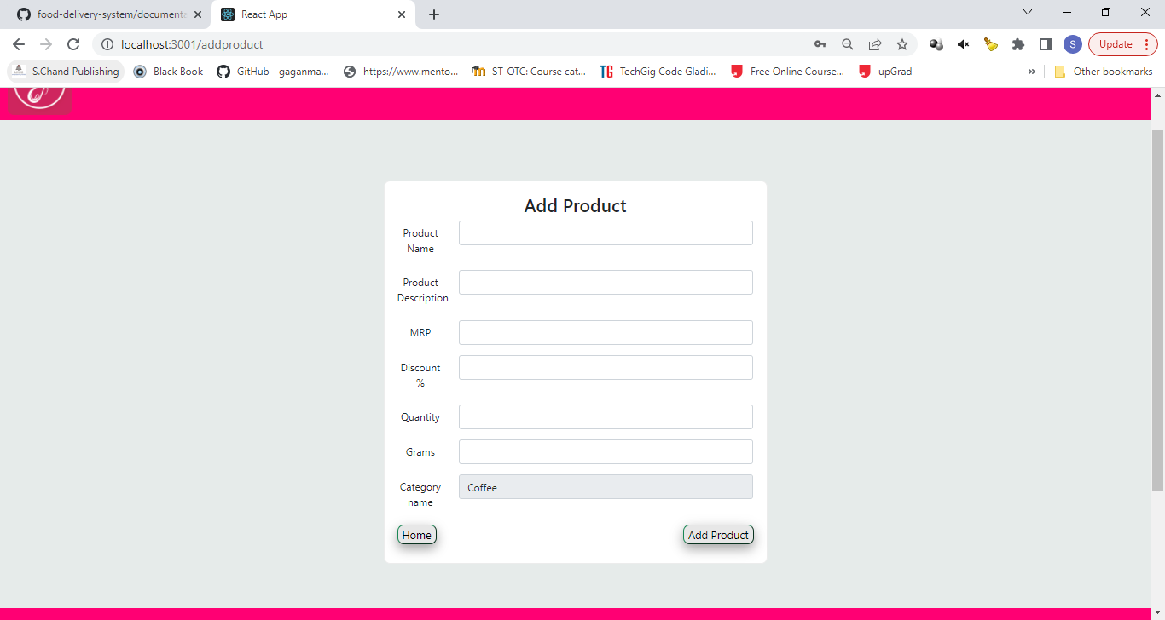

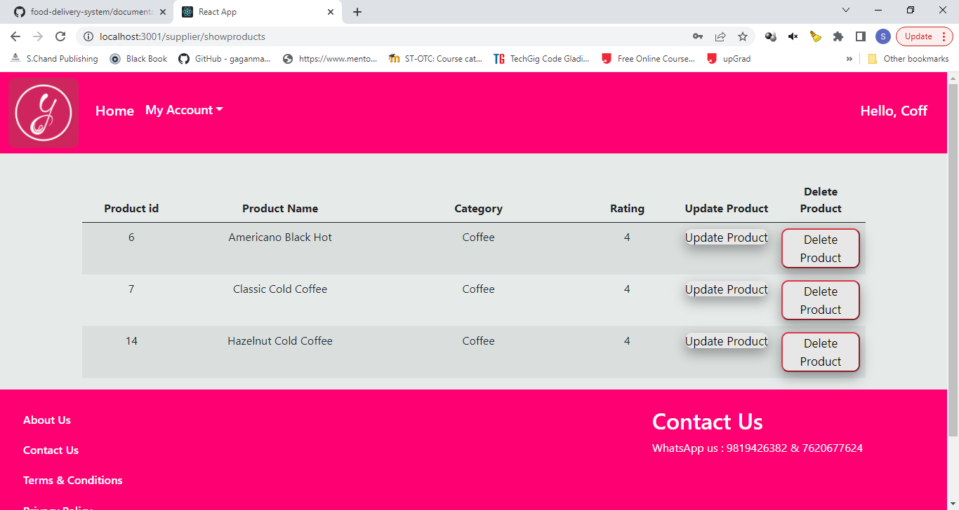

### Customer Login Page

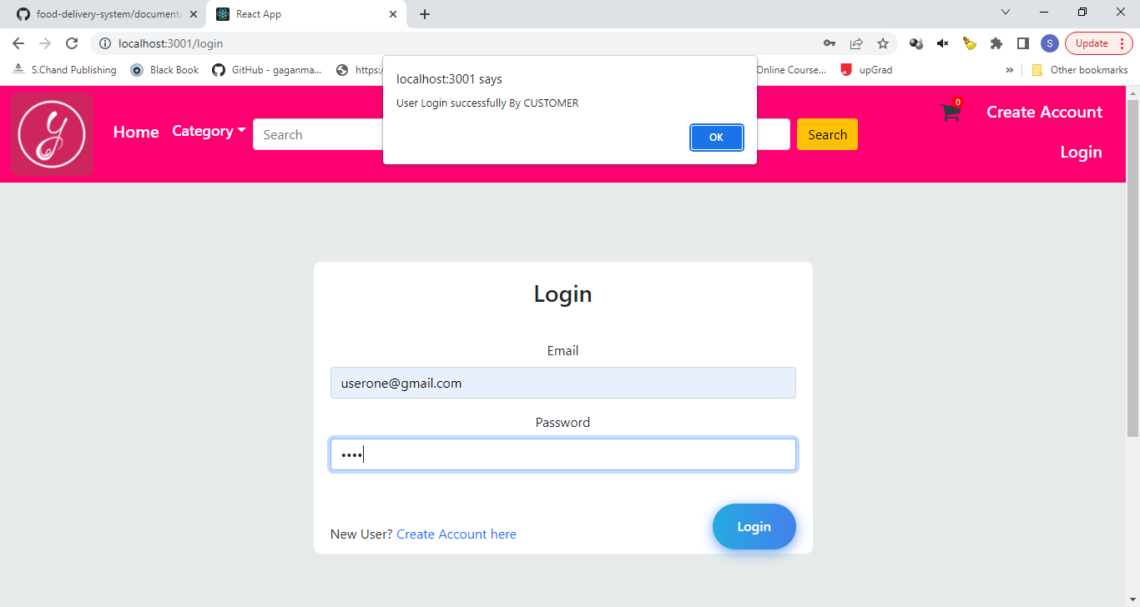

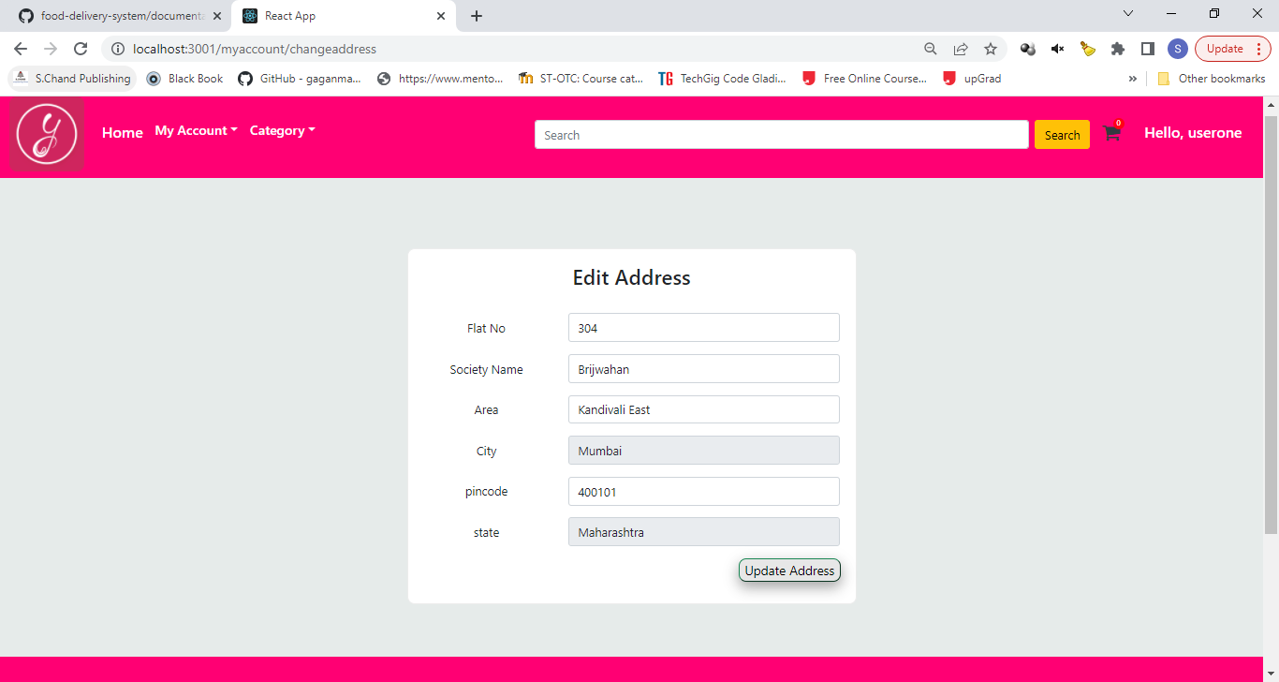

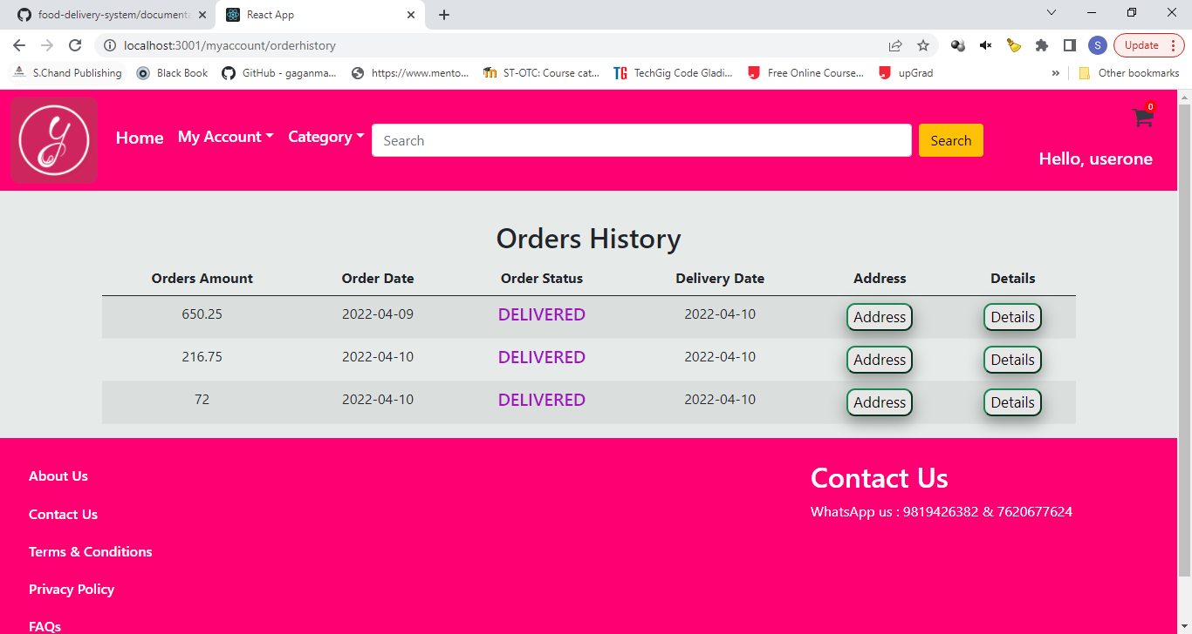

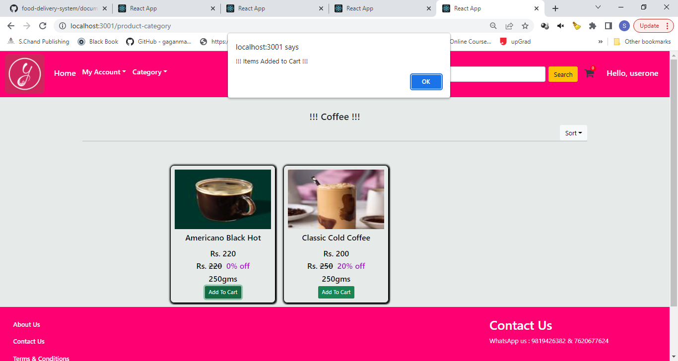

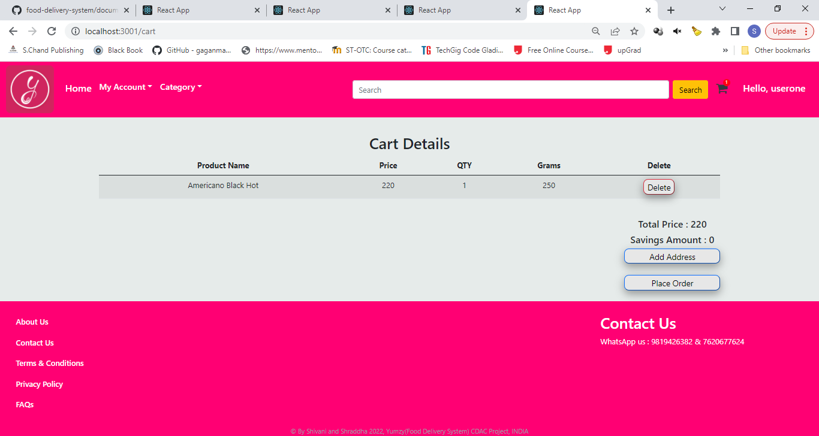

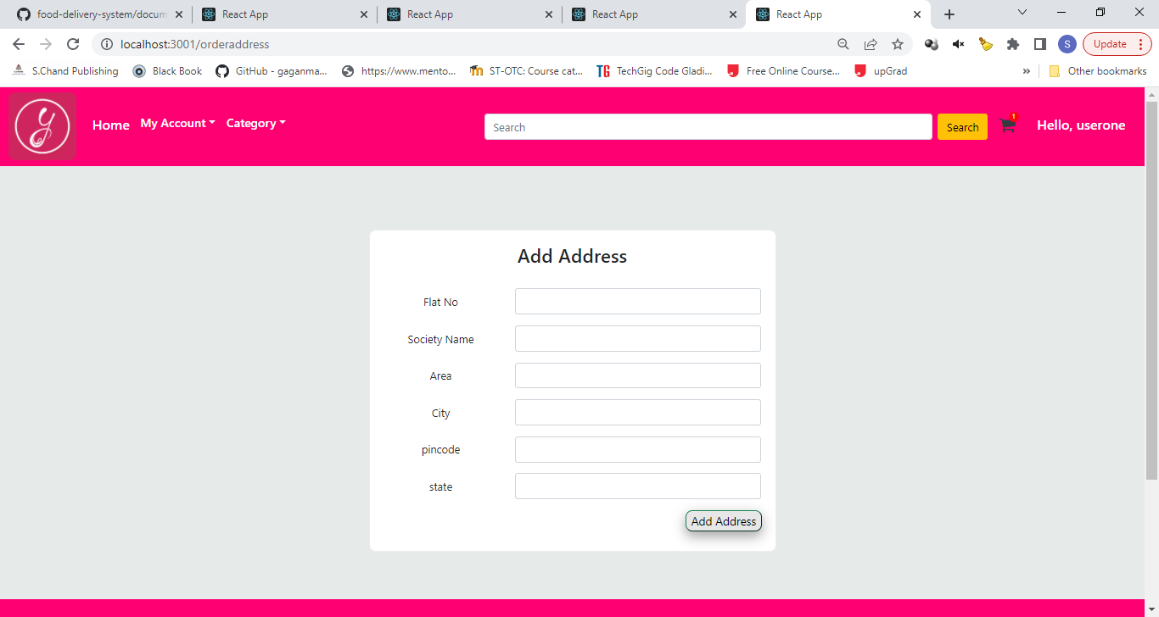

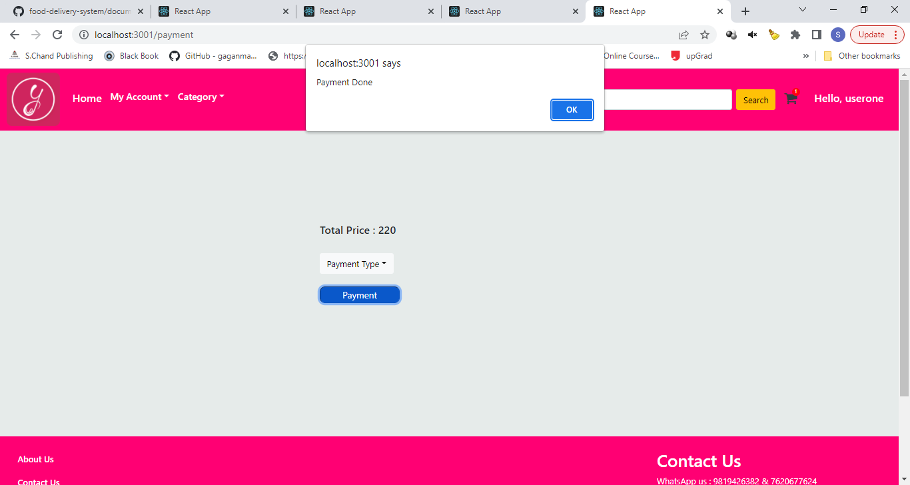

### Delivery Boy Login Page

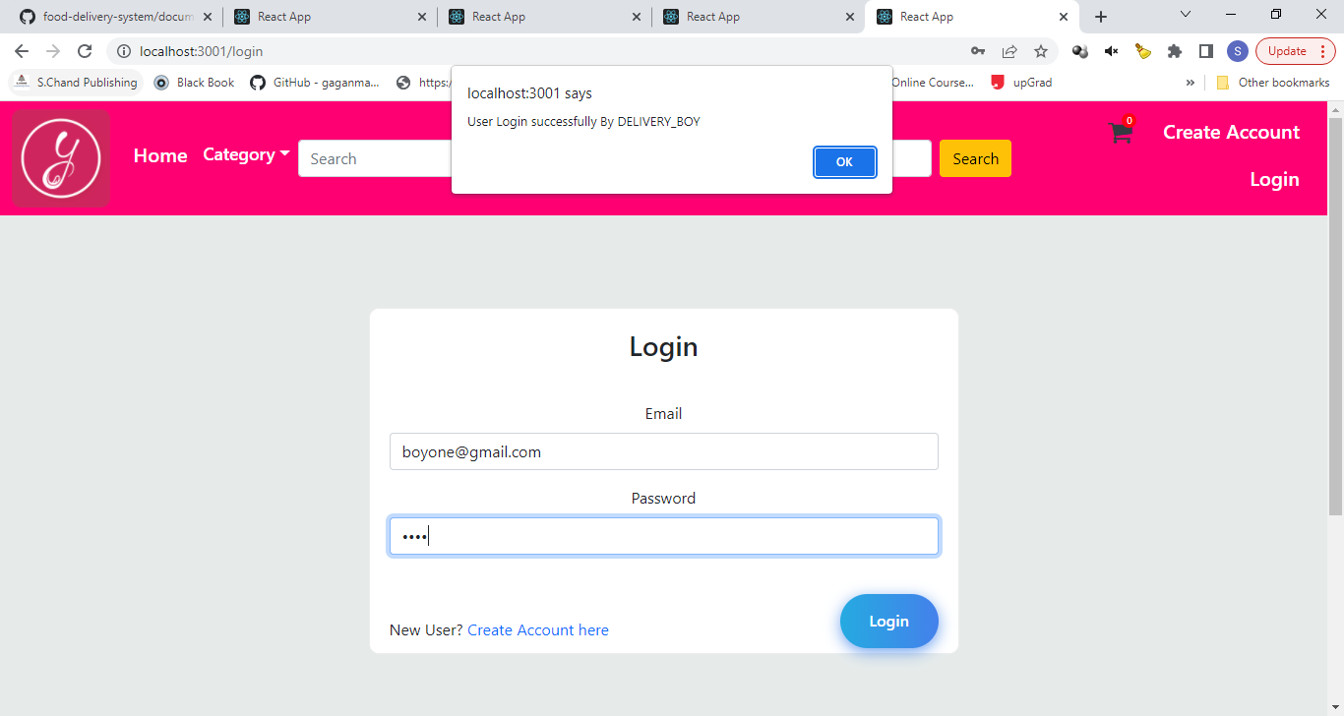

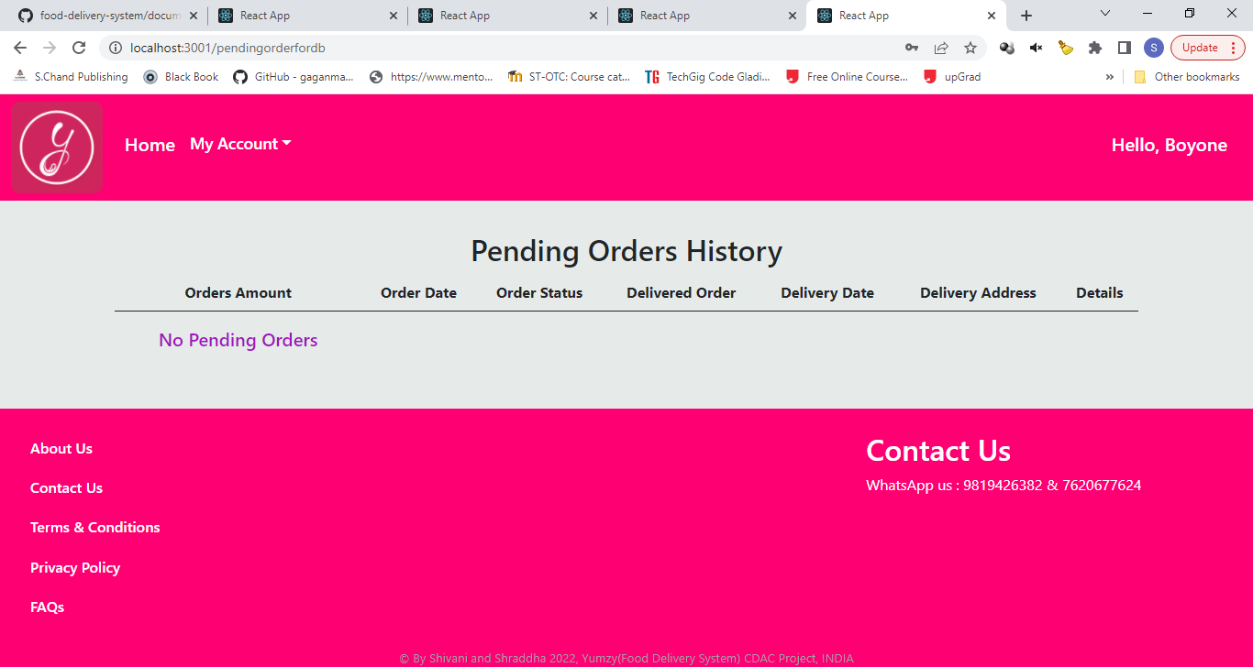

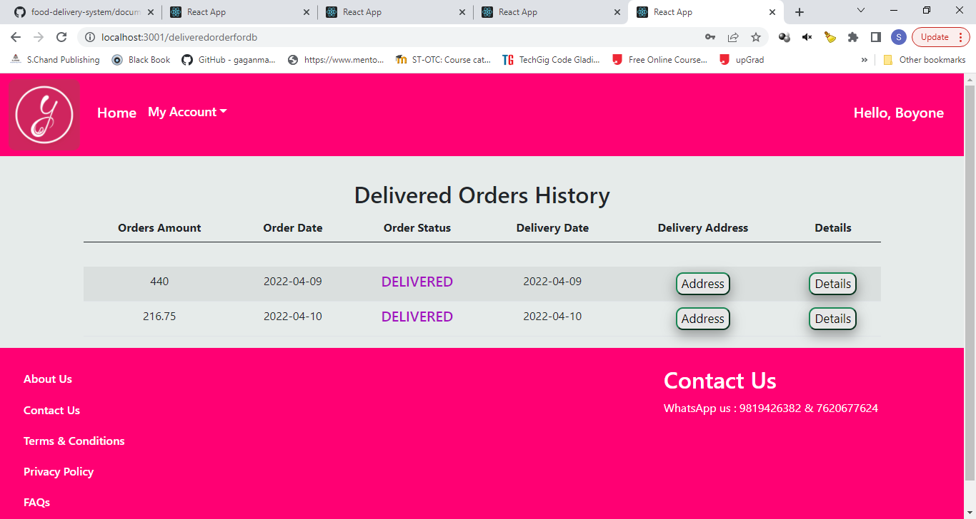

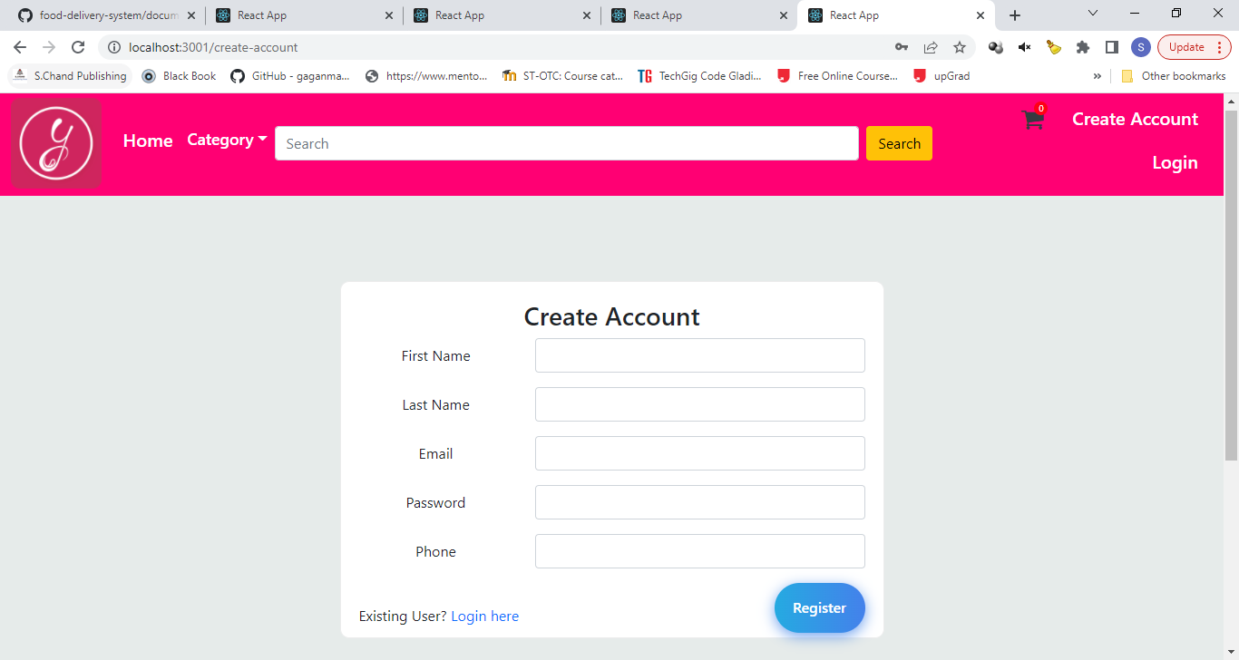

# CONCLUSION

The project entitled **Yumzy** was completed successfully.

The system has been developed with much care and free of errors and at the same time it is efficient and less time consuming. The purpose of this project was to develop a web application for purchasing food items from a Restaurant.

This project helped us in gaining valuable information and practical knowledge on several topics like designing web pages using React.js, usage of responsive templates, designing of android applications, and management of database using MySql. The entire system is secured. Also the project helped us understanding about the development phases of a project and software development life cycle. We learned how to test different features of a project.

This project has given us great satisfaction in having designed an application which can be implemented to any nearby Restaurants or branded Restaurants selling various kinds of food item by simple modifications.

There is a scope for further development in our project to a great extent. A number of features can be added to this system in future like providing moderator more control over food item so that each moderator can maintain their own food item. Another feature we wished to implement was providing classes for customers so that different offers can be given to each class. System may keep track of history of purchases of each customer and provide suggestions based on their history. These features could have implemented unless the time did not limited us.

# REFERENCES

1. JavaScript Enlightenment ,Cody Lindley-First Edition, based onJavaScript 1.5, ECMA-262,

Edition

1. Mc GrawHill’s , Java : The complete reference 7thEdition, Herbert Schildit
2. Complete CSS Guide ,Maxine Sherrin and John Allsopp-O'ReillyMedia; September 2012

## ONLINE REFERENCE

* 1. [www.Google.com](http://www.google.com/)
  2. [www.w3school.com](http://www.w3school.com/)
  3. [www.javatpoint.com](http://www.javatpoint.com/)